1. How to backup and restore redis Database?
2. 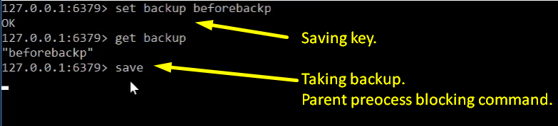  
   **NOTE**: save command would create dumb.rdb file under the redis installation directory. Let’s see it.  
   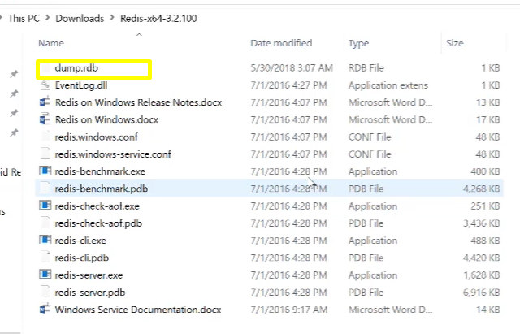
3. 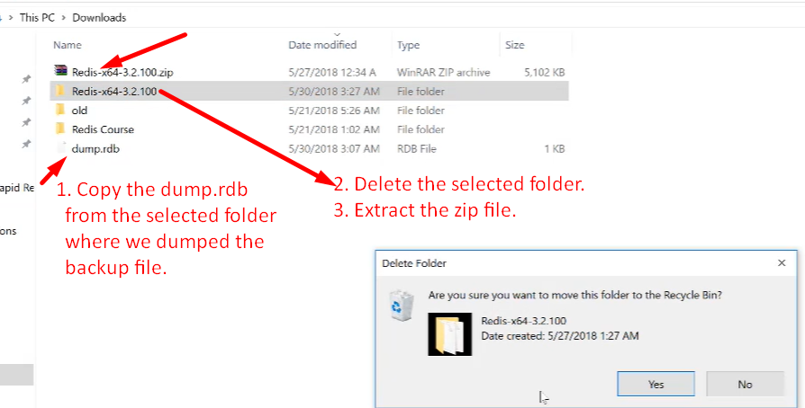
4. 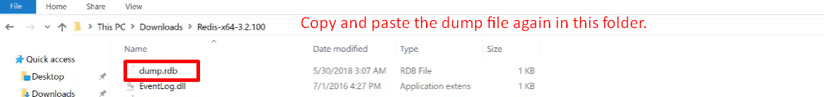
5. That is all you have to do to restore the data from backup. Now just start the redis-cli.